2/5/14 – CSE548 Notes

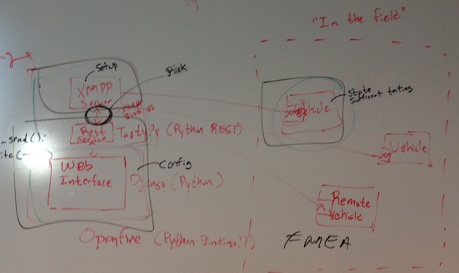

Assumption: Can steal vehicle but not private key

Risk Factors:

1. Connections between components
2. Evaluation of Project depends on proper vehicle agents
3. Improper configurations
4. Correct PKI usage

Tasks :

1. Web Interface
2. Rest Interface w/ XMPP Bindings
3. XMPP Client / Server
4. Vehicle Agent (XMPP Client)

Ideas:

JSON for vehicle commands within the XMPP message 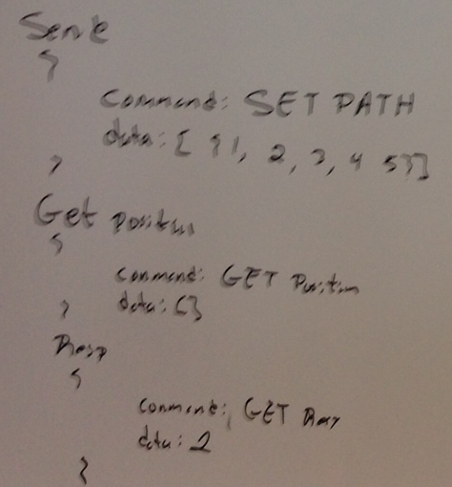

Proposed Vehicle Instructions:

* 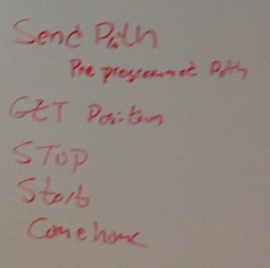Send Path
* Get position
* Stop
* Start
* Come Home

Two user types: 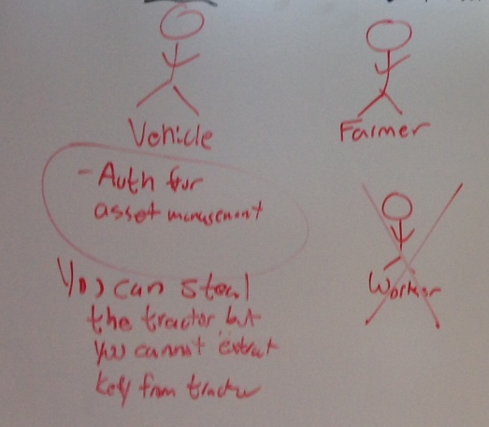

* Vehicle
  + Auths for asset management
* Farmer (manager – superuser)
  + Auths to the web interface

# Risk Management of the project

Describe (a) what potential issues may prevent this project from being successful, (b) what mitigation strategies to prevent/mitigate the identified issues. A good project design should consider what if a task fails. How likely (low, medium, high), the proposed tasks may fail. Are there alternates/makeup/get-arround approaches available? Better use a table to highlight the risks and corresponding mitigation strategy.

Several potential issues have been identified that may pose risk to successful completion of this project. These risks have been identified in the table below. Along with the description, ratings have been assigned to each risk identified, and potential mitigation strategies are described.

|  |  |  |  |
| --- | --- | --- | --- |
| Risk Description | Risk of Failure | Consequence of Failure | Mitigation Strategy |
| Connections between components must be secure | Low | Product would still function, but would lack security – information assurance will suffer | Plan to include security on component connections ahead of time. Follow best practices (SSL/TLS) |
| Evaluation of Project depends on proper vehicle agents | Medium | System is unable to be tested if vehicle agents are inoperable or incorrect | Vehicle agents will be designed first to ensure compatibility with all other components. Thorough review and testing of component to ensure proper functionality |
| Improper configuration of components | Medium | Components do not communicate properly with each other. System functionality is void | Thorough reviews and testing of components to ensure proper functionality and communication |
| Incorrect PKI implementation and/or configuration | Medium | Puts all identified security domains at risk. PKI used becomes useless. System becomes vulnerable to outside attacks i.e. MITM | Follow best practices and standards. No re-invention of the wheel |
| Service Uptime (web reliabity) | High | Product is unusable if network connections are not operable | Redundancy. Cloud hosting to relieviate hardware reliance. |